Matthew Johnson

Data Visualization and Analysis Bootcamp

Excel-Challenge Report

5 April 2023

1. Three conclusions that can be drawn from the data provided are:

* Theater campaigns are the most popular subject/topic from crowdfunding followed by Film & Video and Music. Despite this, the percentage successful vs failed campaigns stay relatively similar across all categories.
* Diving into sub-categories, we find that “Plays” are the driving factor behind Category “Theater” being so popular. However, despite the popularity plays seem only to be successful ~55% of the time.
* 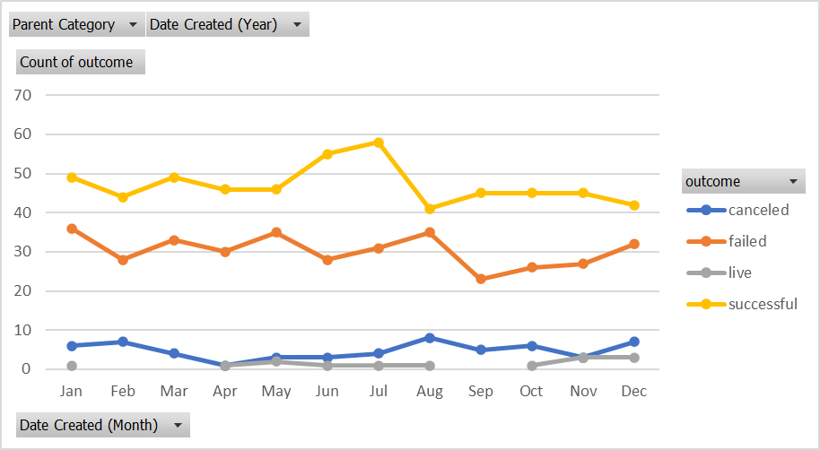While analyzing the date table, we find that campaigns increase during the summer months and plateau throughout the rest of the year. However, crowdfunding campaigns in the Summer also tend to be more successful. This is shown when the successful and failed lines in our Pivot Chart spread farther apart.

1. One limitation of the data set that I found was the outcome “canceled”. I do not believe this gives us a good enough description to categorize this data point. What does it mean for it to be canceled vs. failed? Secondly, the “live” outcome is useless data. If the spreadsheet was live and could keep us updated on whether or not these campaigns end up succeeding or failing then this data point may be useful.
2. One graph I would like to see is a breakdown of each outcome % funded. This would allow is to see how often projects were overfunded or underfunded, and in which categories/sub-categories they occurred most often. You could do a great many charts/graphs for this:
   1. Bar chart showing distribution of % funded.
   2. % funded by category.
   3. % funded by sub-category.